Chronic oral D-galactose intake does not influence Na+/K+ ATPase protein expression in rat’s hippocampus: evidence for effective brain homeostatic mechanisms

Todor Cvetanović

*The Fifth Belgrade Grammar School & Regional Center for Talented Youth Belgrade II, E-mail: cvetanovictodor@gmail.com*

Supervisor: Marina Zarić, MSc, Research Assistant at VINČA Institute of Nuclear Sciences, University of Belgrade, Belgrade, Serbia

# *Introduction*

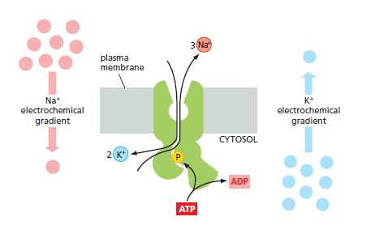Chronic injection of D-galactose (D-gal) in rodents stimulates the symptoms of natural senescence leading to cognitive fading and motor skill enervation and thus represents a reliable brain ageing model [1]. However, data regarding effects of chronic oral D-gal treatment still remain scarce. The Na+/K+ pump, or Na+/K+ ATPase, is the protein responsible for the ATP-dependent, coupled transport of sodium and potassium ions across the plasma membrane. The Na+/K+ pump is found on the surface of all animal cells and represents a major force in maintaining the concentration gradients of these ions across the membrane [2]. These gradients provide energy for most important cellular functions including maintenance of cell’s resting potential, regulation of cell volume and pH and uptake of nutrients and water [3]. In order to test potential effect of chronic oral D-gal intake on neurons that are most vulnerable to brain ageing and taking into account all essential functions of Na+/K+ ATPase, the aim of this study was to investigate protein expression of Na+/K+ ATPase in rat’s hippocampus.

Picture 1. The function of Na+/K+ pump- schematic representation of Na+/K+ ATPase transport mechanism

# *Material and methods*

Three-month old male Wistar rats were subjected to 6 weeks D-gal treatment (200 mg/kg dissolved in tap water). At the end of the treatment, the animals were decapitated with a guillotine without anesthesia, brains were removed and hippocampi were dissected. Protein expression of Na+/K+ ATPase in hippocampal crude synaptosomal fraction was determined by Western blot method. All data were expressed as means ± S.E.M. percentages of control. β-actin was used as a loading control. The differences among the two groups were analyzed by unpaired t-test. P< 0.05 was defined as statistically significance.

Figure 1. Na+/K+ ATPase protein expression determined by western blotting. All data were expressed as means ± S.E.M percentages of control; n=3, p < 0.05

# *Results and discussion*

Results showed no significant difference in Na+/K+ ATPase protein expression between control and 200 mg/kg D-gal group. Results indicate that chronic oral D-gal intake does not influence Na+/K+ ATPase protein expression in rat’s hippocampus.

# *Conclusion*

This experiment represents an important evidence that brain has various coping mechanisms which help homeostasis maintenance and regulation of essential molecular players in physiological ranges. Moreover, this study provides the "relief" that some of our bad eating habits cannot deregulate our effective gate keeper mechanisms in the brain. Further research that will elucidate these mechanisms needs to be done. In order to correctly validate the obtained results other D-gal doses should be tested. Furthermore, research should be carried out on other rat strains/ rodent species and on female subjects to exclude potential gender differences.

# References

1. Cui X, Zuo P, Zhang Q, Li X, Hu Y, Long J, et al. Chronic systemic D-galactose exposure induces memory loss, neurodegeneration, and oxidative damage in mice: protective effects of R-alpha-lipoic acid. J Neurosci Res. 2006;83[8]:1584-90.

2. Horisberger JD. Recent insights into the structure and mechanism of the sodium pump. Physiology [Bethesda]. 2004;19:377-87.

3. Tsakiris S, Marinou K, Schulpis KH. The effect of galactose metabolic disorders on rat brain Na+,K+-ATPase activity. Z Naturforsch C. 2002;57[9-10]:939-43.